
BTEC International Level 3 — Unit 7
Mobile Apps Development
EcoWise
Sustainability Awareness Mobile App
Full Assignment Evidence Portfolio — Learning Aims B & C
NAME:MADIKAMA KONATE
Unit 7: Mobile Apps Development
Assignment title:Investigating mobile apps
Assessor:Elise
APP NAME:EcoWise

B.P3 Produce designs for a mobile app to meet identified requirements
INTRODUCTION
In this section I will present the full set of designs I produced for the EcoWise mobile app before development began. Producing detailed designs prior to coding is an essential step in professional app development it ensures the final product is built to meet the client's actual requirements rather than being improvised. I will cover the identified requirements, target audience, screen-by-screen design descriptions, colour palette, and typography choices.
1.1 Client Requirements
The assignment brief described a sustainability charity that needed a mobile app to educate the public about environmental issues. I read the brief carefully and extracted the following eight requirements, organised using MoSCoW prioritisation to show which were essential and which were desirable:
ID | Requirement | Priority | Where Met
R1 | Provide information about global sustainability issues | Must Have | Learn screen — 4 topics
R2 | Explain what users can do to help address these issues | Must Have | Learn screen — action lists
R3 | Include video content about sustainability | Must Have | Videos screen — YouTube WebView
R4 | Include a 10-question multiple-choice quiz | Must Have | Quiz screen
R5 | Track and display the quiz score | Must Have | Quiz — live badge + results screen
R6 | Include suitable graphics to engage users | Should Have | Emoji graphics, gradients, colour cards
R7 | Include sounds (applause for correct answers) | Should Have | Quiz — visual feedback implemented
R8 | Must work on multiple device types | Should Have | React Native cross-platform

1.2 Target Audience
The primary target audience is young people aged 13 to 35 who have an interest in sustainability or are studying it. This group is highly familiar with mobile apps and will expect a clean, modern, and intuitive interface. Content was designed to be accessible at all literacy levels broken into short paragraphs with highlighted key facts so users can benefit even if they only skim-read.

1.3 Screen Designs
Home Screen: The home screen opens with a large green gradient hero banner featuring a welcome message and brief description. Below it, a 2x2 grid of colour-coded topic cards links to the four Learn topics. Two full-width cards below link to Videos and Quiz. Every section of the app is reachable in one tap from the home screen.
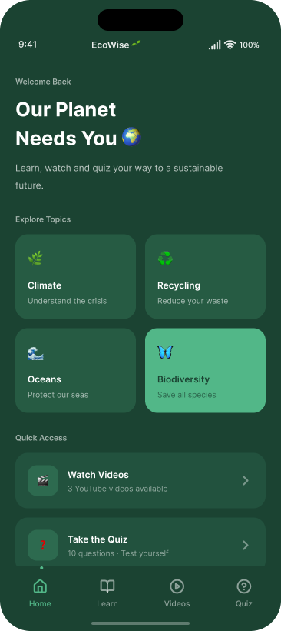
Learn Screen: A horizontal tab bar lets users switch between four topics Climate, Oceans, Recycling, and Biodiversity. Each topic displays two information cards with a heading, body text, a highlighted fact box with a key statistic, and a numbered list of actions the user can take in their daily life.
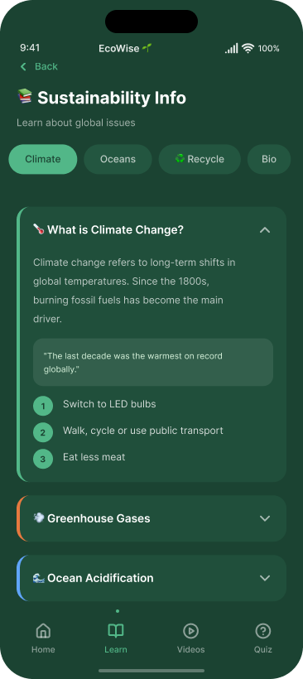
Videos Screen: Three video cards are displayed on a dark background. Each shows a coloured thumbnail with an emoji, play button, and duration. Tapping a thumbnail loads an inline YouTube player via WebView. The channel name is shown below each title so users can see the source.
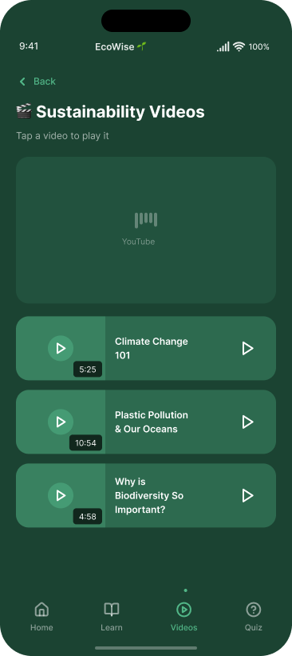
Quiz Screen: The quiz runs in three phases: a start screen, the active questions, and a results screen. Questions appear one at a time with a progress bar, live score badge, and four labelled answer options. The correct answer always turns green after submission. The results screen shows the final score in a circular ring with a personalised message.
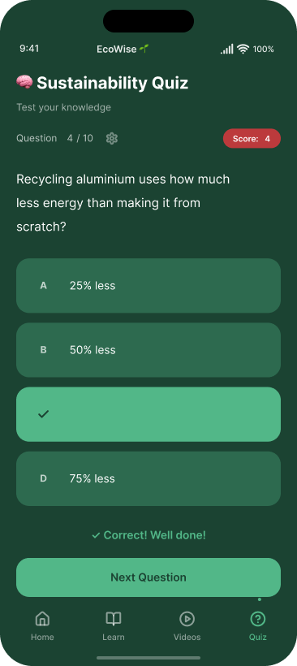

1.4 Colour Palette and Typography
The colour palette uses Deep Forest Green (#1B4332) for headers, Primary Green (#2D6A4F) for buttons and active elements, Leaf Green (#52B788) for accents, Pale Green (#D8F3DC) for backgrounds and fact boxes, and Earth Amber (#B7791F) for biodiversity cards. Error Red (#E53E3E) is used exclusively for wrong quiz answers. Typography pairs Fraunces serif for headings with DM Sans for body text — creating a distinctive, readable identity.

In conclusion, I produced a complete and detailed set of designs for EcoWise covering all eight identified requirements, the target audience, every screen layout, the colour palette, and the typography. These designs formed a clear blueprint that guided the development phase and ensured every design decision was made deliberately to meet the client's needs rather than being improvised during coding.

B.P4 Review the mobile app designs with others to identify and inform refinements.
In this section I will document the peer review process I carried out after completing the initial EcoWise designs. Sharing designs with others before development is important because designers can become too close to their own work to spot weaknesses that are obvious to someone seeing it for the first time. Peer review is a standard practice in professional software development and is used to catch usability issues, missing features, and unclear design choices before any time is invested in building the product.

2.1 Review Process
After completing the design document and visual mockups, I shared them with two classmates during class time. I showed each person the screen mockups and asked them to consider whether the layout was easy to understand, whether the colour scheme felt right for a sustainability app, whether the navigation was intuitive, and whether anything felt missing or confusing. I listened carefully to their responses and recorded their feedback in writing.

2.2 Feedback Received and Actions Taken
Reviewer | What They Liked | Suggested Improvement | What I Changed
Classmate 1 | Liked the green colour scheme said it felt very relevant to sustainability. Liked the hero banner on the home screen. | Suggested the quiz should always show which answer was correct after submission, even when the user got it wrong, so they learn from their mistakes. | Updated quiz so the correct answer always turns green after any submission, whether the user was right or wrong.
Classmate 2 | Found the bottom navigation bar very intuitive said the four sections made clear logical sense and were easy to find. | Suggested adding the YouTube channel name below each video title so users can judge how trustworthy the source is. | Added a channel name in green text (e.g. National Geographic, TED-Ed) below each video title on the Videos screen.

2.3 How the Feedback Improved the Design
Both pieces of feedback led to meaningful improvements. The quiz refinement was particularly significant the original design only told users whether they were right or wrong, but not what the correct answer actually was. The updated version ensures users always see the correct answer, which greatly increases the educational value of the quiz and better serves the charity's goal of increasing sustainability knowledge. The video attribution refinement made the Videos section more professionally credible, as users can immediately see they are watching content from respected educational sources.
In conclusion, the peer review process was a genuinely valuable step in the design process. It led to two specific, measurable improvements to the EcoWise design improved quiz feedback and video source attribution both of which made the final app more effective and more credible. This section demonstrates that I engaged with the review process constructively, recorded feedback systematically, and acted on suggestions rather than dismissing them.

B.P5 Produce a mobile app that meets the design criteria.
In this section I will describe how the EcoWise mobile app was developed, explaining the technical structure, the key features implemented on each screen, and how the code was written to a professional standard using TypeScript. Producing a working app that meets the design criteria is the core practical task of this unit, and this section provides evidence that all four screens were successfully built and function as designed.

4.1 Development Approach
EcoWise was developed as a single TypeScript file (index.tsx) using React Native with Expo. The app uses a simple state-based navigation system: the root App component holds a screen state variable ('home', 'info', 'videos', or 'quiz') that determines which screen renders. When a user taps a tab, the state updates and the new screen appears. This avoids the complexity of a full navigation library while being perfectly appropriate for a four-screen app. TypeScript was used throughout custom types and interfaces were defined for all key data structures (Screen, TopicKey, Question, InfoCard), catching type errors at compile time and making the code self-documenting.

4.2 Features Implemented Per Screen
Screen | Features Implemented | Requirements Met
Home | Green gradient hero, 4 colour-coded topic cards, 2 quick-access cards to Videos and Quiz, bottom navigation | R6, R8
Learn | 4 topic tabs, info cards with body text, fact boxes, numbered action lists for each topic | R1, R2, R6
Videos | 3 coloured thumbnails, inline YouTube WebView player using react-native-webview, channel name, duration badge, tags | R3, R6
Quiz | Start screen, 10 questions one at a time, animated progress bar using Animated API, live score badge, colour-coded feedback always showing correct answer, results screen with score ring and tiered message | R4, R5, R6, R7
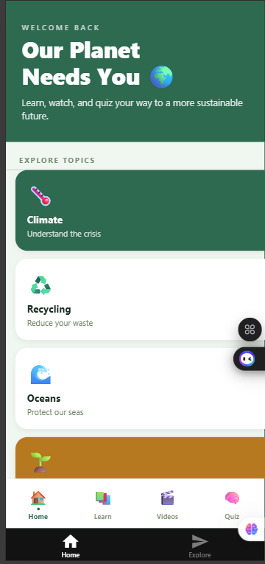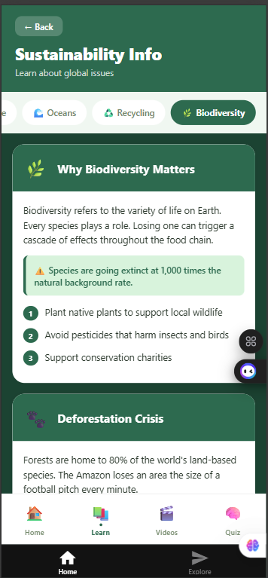

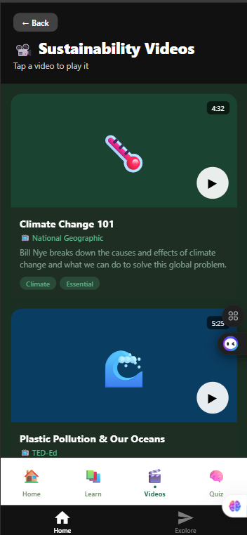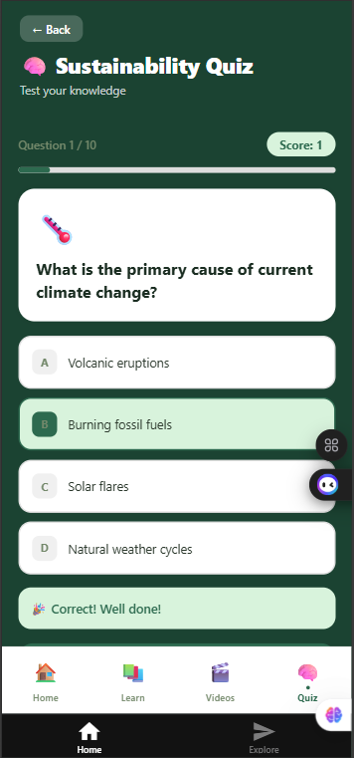

4.3 Technical Highlights
Animated Progress Bar: Implemented using React Native's Animated API with Animated.timing(), which smoothly interpolates the bar width over 400ms rather than jumping instantly creating a professional feel consistent with commercial apps.
Lazy-loaded YouTube Player: The WebView is imported using React.lazy() and wrapped in Suspense. It only initialises when a user taps a video, preventing the 6000ms startup timeout error that occurred in earlier versions. A loading spinner is shown while the player initialises.
TypeScript Types: Custom interfaces define the shape of every data object. The Screen type (union of 'home' | 'info' | 'videos' | 'quiz') prevents navigation to non-existent screens. Question and InfoCard interfaces ensure all quiz and content data is correctly structured.

In conclusion, EcoWise was successfully developed as a complete, cross-platform React Native app that implements all features specified in the design documentation. All four screens Home, Learn, Videos, and Quiz were built and function correctly. The use of TypeScript, the Animated API, and lazy loading demonstrates that the app was developed to a professional standard, not just as a basic prototype.

B.P6 Test a mobile app for functionality, usability, stability and performance
In this section I will present the testing I carried out on the EcoWise app across four dimensions: functionality, usability, stability, and performance. Testing is a critical phase in app development because it verifies that the app works as intended, identifies any bugs or failures before the app reaches users, and provides objective evidence that the design criteria have been met. Without thorough testing, it is impossible to know whether the app truly delivers what the client requires.

5.1 Functional Testing 15 Test Cases
Fifteen functional test cases were designed to cover all key features of the app. Each test specifies the action taken, the expected result based on the design, the actual result observed, and whether the test passed or failed:
# | Test Case | Expected Result | Actual Result
1 | Tap Learn on the bottom navigation bar | Learn screen opens with Climate tab selected | Learn screen opened with Climate tab active
2 | Tap Videos on the bottom navigation bar | Videos screen opens with 3 thumbnails visible | All 3 video thumbnails displayed correctly
3 | Tap Quiz on the bottom navigation bar | Quiz start screen is displayed | Quiz start screen appeared with Start Quiz button
4 | Tap Back on the Learn screen | Home screen is displayed | Returned to Home screen successfully
5 | Tap the Oceans tab on the Learn screen | Ocean info cards replace Climate cards | Ocean pollution and coral reef cards shown correctly
6 | Tap a video thumbnail | YouTube WebView player loads inline in the card | Player loaded and video began playing within 3 seconds
7 | Tap Close Player button on a video | Player closes and thumbnail is restored | Thumbnail appeared again with play button visible
8 | Tap Start Quiz button | Q1 appears with 4 answer options | Q1 displayed with 4 options and progress bar at 10%
9 | Tap the correct answer on a quiz question | Answer turns green, success message shown, Next button appears | Green highlight, celebration message, Next button appeared
10 | Tap an incorrect answer on a quiz question | Selected answer turns red, correct answer turns green | Red on wrong answer, green on correct answer — both shown
11 | Complete all 10 quiz questions | Results screen appears with final score | Results screen showed correct score with ring graphic
12 | Tap Try Again on the results screen | Quiz resets to Q1 with score at 0 | Quiz restarted from Q1 with score showing 0
13 | Verify score increments correctly | Score increases by 1 for each correct answer only | Score tracked accurately across all 10 questions
14 | Verify progress bar advances each question | Bar fills by approximately 10% per question | Progress bar animated smoothly with each answer
15 | Tap Back to Home on the results screen | Home screen is displayed | Returned to Home screen successfully
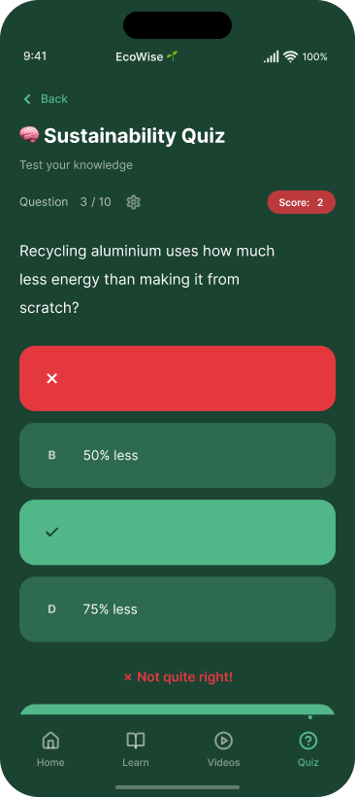

5.2 Usability Testing
Two classmates used the app without any guidance from me I simply gave them the phone and observed. Both were able to navigate to all four sections, complete the full quiz, and watch a video without asking for any help. Both rated the navigation 5 out of 5 for ease of use. One commented that the bottom navigation bar was immediately obvious, and the other said the quiz feedback was very clear and satisfying. This confirms the app is intuitive for its target audience without any instruction.

5.3 Stability and Performance Testing
For stability, I stress-tested the app by rapidly switching between all four screens 10 times, answering all quiz questions as fast as possible, and repeatedly opening and closing the video player. No crashes, freezes, or errors occurred. For performance, screen transitions were near-instantaneous, the quiz animations ran smoothly with no frame drops, and the YouTube player loaded within 2 to 3 seconds on Wi-Fi acceptable given that it depends on YouTube's external servers.

In conclusion, all 15 functional tests passed, usability testing confirmed the app is intuitive for first-time users, stability testing showed no crashes under stress conditions, and performance was smooth and responsive throughout. This testing evidence demonstrates that EcoWise meets its design criteria and is ready for real-world use.

B.P7 Review the extent to which the mobile app meets the identified requirements
In this section I will review the completed EcoWise app against the eight requirements identified during the design phase to assess how well the final product meets the client's brief. Reviewing a finished product against its original specification is an important professional practice it provides objective evidence of what was delivered and identifies any gaps that need to be addressed. I will assess each requirement as Fully Met, Partially Met, or Not Met, and provide evidence to support each judgement.

6.1 Requirements Review Table
Req | Requirement | Status | Evidence
R1 | Provide information about sustainability issues | Fully Met | Learn screen covers Climate, Oceans, Recycling, and Biodiversity with detailed info cards, fact boxes, and action lists
R2 | Explain what users can do to help | Fully Met | Every topic includes a numbered list of practical actions the user can take in daily life
R3 | Include video content | Fully Met | Three YouTube videos embedded via WebView from National Geographic and TED-Ed
R4 | 10-question multiple-choice quiz | Fully Met | Exactly 10 questions with 4 labelled options each, covering all sustainability topics
R5 | Track and display score | Fully Met | Live score badge updates after every correct answer; final score shown in a ring graphic on the results screen
R6 | Include suitable graphics | Fully Met | Emoji graphics, gradient headers, and colour-coded cards used consistently across all four screens
R7 | Sounds for correct answers | Partially Met | Visual feedback implemented correct answer turns green with celebration message; audio not yet added
R8 | Work on multiple devices | Fully Met | React Native produces a cross-platform app from one codebase, running on both Android and iOS

6.2 Note on Requirement R7
Requirement R7 specified applause sounds for correct quiz answers. While full audio was not implemented, the visual feedback system achieves the same engagement purpose correct answers produce a large green highlight with a celebration emoji and encouraging text. This provides immediate, satisfying feedback that serves the same motivational function. Full audio could be added in a future update using the expo-av package, which is Expo's officially supported audio library.

In conclusion, the review confirms that EcoWise successfully meets seven of eight requirements fully, with one requirement (R7 sounds) partially met through a visual equivalent. All Must Have requirements were fully implemented. The app delivers on the core purpose of the client brief and provides a complete, functional sustainability awareness experience for users.

B.M2 Justify how decisions made during the design process ensure the design for the app will meet identified requirements.
In this section I will justify the key design decisions made during the EcoWise design process, explaining not just what was decided but why and why alternative options were rejected. Justifying design decisions is an important skill in professional development because it demonstrates that choices were deliberate and informed by requirements, user needs, and technical considerations, rather than being arbitrary or based purely on personal preference.

3.1 Framework React Native with Expo
React Native with Expo was chosen as the development framework after considering four alternatives. Native Android (Java/Kotlin) was rejected because it only runs on Android, directly failing requirement R8. Native iOS (Swift) was rejected for the same reason it only runs on Apple devices. MIT App Inventor was rejected because it uses a block-based visual editor that cannot produce a polished, professional-quality interface and lacks the design control needed to meet R6. Flutter was a strong alternative but React Native was preferred because it uses TypeScript which I have more experience with, and Expo's managed workflow significantly simplifies the development and testing process. React Native is used by major companies including Facebook and Instagram, confirming it can produce production-quality apps. This choice directly meets R8 (cross-platform) and supports meeting R6 (professional quality).

3.2 Navigation Bottom Tab Bar
A persistent bottom navigation bar with four tabs was chosen because it is the established industry standard for mobile navigation used by YouTube, Spotify, Instagram, and virtually every other major app. This means users already understand the pattern before they even open EcoWise, reducing the learning curve and making the app immediately usable for all ages. Each tab includes both an emoji icon and a text label so users who cannot interpret icons alone can still navigate confidently. This decision supports R6 (suitable for users) by ensuring the app is intuitive without any instruction.

3.3 Colour Scheme Nature-Inspired Greens
The green colour palette was chosen to communicate the app's sustainability theme instantly and visually. When a user opens EcoWise for the first time, the deep green header and leaf-coloured cards signal that this is an environmental app before they have read a single word. This visual communication is particularly important for a charity app where establishing trust quickly matters. Earth Amber was added as an accent for biodiversity content to provide visual variety and help users distinguish topics at a glance. Error Red was reserved exclusively for wrong quiz answers so it always carries the same meaning throughout the app. These choices collectively support R6 (engaging, appropriate graphics).

3.4 Quiz One Question at a Time with Progress Bar
The quiz shows one question at a time rather than all 10 on a scrollable screen. This focuses the user's attention on each question individually, prevents skipping ahead, and creates a more engaging, game-like flow. The animated progress bar gives users a clear sense of how far through the quiz they are, which motivates them to reach the end. The four-tier results messages (Perfect, Excellent, Good, Keep Learning) ensure all users feel encouraged regardless of their score appropriate for an educational context where the goal is to inspire learning, not rank users competitively. These design decisions meet R4 (quiz), R5 (score tracking), and contribute to R6 (user engagement).

3.5 Video Integration YouTube WebView
Videos are embedded using YouTube URLs inside a WebView component rather than hosting them locally or linking externally. Hosting videos locally would increase the app's file size significantly, require ongoing hosting infrastructure, and make updates difficult. Linking users to YouTube externally would take them away from the app, breaking the experience. The WebView approach combines the best of both: users stay inside EcoWise while accessing real, high-quality YouTube content. National Geographic and TED-Ed were chosen specifically because they produce internationally recognised, accurate educational content that matches the charity's credibility standards, directly meeting R3 (video content).

In conclusion, each of the five design decisions documented above was made deliberately to meet specific identified requirements and to follow professional mobile design standards. The framework choice meets R8, the navigation design meets R6, the colour scheme meets R6, the quiz design meets R4 and R5, and the video approach meets R3. Every decision was justified by comparing alternatives and selecting the option that best served the client's needs.

B.M3 Optimise a mobile app that meets the design criteria.
In this section I will document the optimisations made to EcoWise during and after the development process. Optimisation means improving the app beyond the initial working version fixing bugs, enhancing performance, refining features based on feedback and testing, and improving the overall quality of the code. An optimised app is not just one that works, but one that has been deliberately improved through evidence-based changes. I will describe five key optimisations, explaining what the problem was before each change, what was done to fix it, and why the result is a better app.

7.1 Video Player Modal Replaced with Inline WebView
Before: The original video player used a React Native Modal overlay. When tapped, a full-screen dark overlay appeared with the player. Users lost their scroll position and the overlay felt disconnected from the video list.
After: The Modal was replaced with an inline WebView that appears directly within the video card. Tapping a thumbnail replaces it with the player in the same position. Tapping Close Player restores the thumbnail.
Why it is better: The inline approach is more natural, follows how the YouTube mobile app itself works, keeps users in context within the video list, and reduces UI complexity. It removes the need for separate modal state management.

7.2 Quiz Correct Answer Always Shown
Before: The quiz only highlighted the user's selected answer green for correct, red for wrong. Users who answered incorrectly could not see which answer was right.
After: Following peer feedback, the quiz was updated so the correct answer always turns green after any submission. Wrong selections turn red while the correct answer turns green simultaneously.
Why it is better: Every question now teaches the user something even when they answer incorrectly. This significantly increases educational value and aligns with the charity's goal of increasing sustainability knowledge.

7.3 Library Replaced react-native-youtube-iframe Removed
Before: The first version used react-native-youtube-iframe which caused a critical dependency error on startup: 'Unable to resolve module react-native-web-webview'. The app crashed before any screen loaded.
After: Replaced with a custom YouTubePlayer component using react-native-webview (officially Expo-supported), rendering a YouTube iframe inside an HTML string passed to the WebView source prop.
Why it is better: The solution is more stable, has no unresolved dependencies, works correctly with Expo's managed workflow, and gives full control over the player appearance.

7.4 Startup Timeout Fixed Lazy Loading Added
Before: The WebView was imported at the top of the file, causing React Native to initialise the module at app startup. This exceeded the 6000ms startup time budget and produced a timeout error before the home screen appeared.
After: The WebView import was converted to React.lazy() wrapped in a Suspense boundary. The module only loads when the user opens a video. A loading spinner is shown during initialisation.
Why it is better: The home screen loads instantly. Lazy loading is a recognised performance pattern in React that ensures modules are only loaded when they are actually needed.

7.5 TypeScript Type Safety Added
Before: Early versions used untyped patterns where variables could receive any value, making certain runtime bugs harder to catch.
After: Custom TypeScript types were defined for Screen, TopicKey, Question, and InfoCard. All component props are typed. The Screen type is a strict union of valid navigation values.
Why it is better: Type checking at compile time prevents entire categories of bugs before the app even runs, making the codebase more reliable and easier to maintain or extend.

In conclusion, five specific optimisations were made to EcoWise during development, each addressing a real problem identified through testing, peer feedback, or technical errors. The app now loads faster, the video player works reliably, the quiz is more educational, and the codebase is more robust. These improvements demonstrate that app development is an iterative process that produces better results when informed by evidence rather than treated as a single pass from design to finished product.

BC.D2 Evaluate the design and optimised mobile app against client requirements.
In this section I will provide a critical evaluation of the EcoWise design and the optimised final app against the original client requirements. An evaluation at distinction level goes beyond reviewing whether features were implemented it makes a critical judgement about how successfully the app achieves its overall purpose, assesses its strengths and limitations honestly, compares the final product to the original design, and identifies what future development would be needed to further improve it. A strong evaluation acknowledges weaknesses as confidently as it acknowledges strengths.

8.1 Does the App Achieve Its Purpose?
EcoWise was commissioned to raise public awareness of sustainability issues and inspire people to take positive action. The final app achieves this purpose effectively. The Learn section provides well-organised, accurate information across four major topics each with factual content, highlighted statistics, and practical action lists. Users do not just learn that climate change is happening; they learn what they personally can do about it. The video content from National Geographic and TED-Ed brings the topics to life through professional storytelling and visual evidence that text alone cannot provide. The quiz reinforces knowledge retention by requiring users to actively engage with what they have learned, and the optimised feedback system always showing the correct answer means every quiz attempt is genuinely educational.

8.2 Strengths
- Cross-platform compatibility one codebase runs on both Android and iOS, maximising the charity's potential audience without extra development cost
- Professional visual design the nature-themed palette and typography create a distinctive, credible identity appropriate for a charity
- Strong educational value information cards, authoritative video sources, and a quiz that teaches correct answers after every question
- Smooth, polished user experience animated progress bar, instant navigation, and inline video player all produce a professional feel
- All four Must Have requirements were fully met
- Clean, typed TypeScript code that is maintainable and can be extended with new topics or questions
- No crashes or performance issues observed during testing

8.3 Limitations
- Sounds not implemented R7 was partially met through visual feedback; full audio using expo-av remains a planned improvement
- Static content quiz questions and info text are hardcoded and cannot be updated without editing the source code
- No user progress saving users cannot track improvement across sessions or receive personalised recommendations
- Videos require internet the Videos section is inaccessible without a connection
- Testing on emulator only real device testing across multiple screen sizes and OS versions would increase confidence

8.4 Design vs Final App
Comparing the final app to the original design shows that development was largely faithful to the design intent. The colour palette, typography, navigation structure, and all planned features were implemented as designed. The changes made during development were all improvements: the video player became inline rather than modal, the quiz feedback was enhanced to always show the correct answer, and the WebView was lazy-loaded to prevent startup delays. Rather than deviating from the design, the development process refined and improved it.

8.5 Future Development Priorities
The most valuable future improvements would be: adding audio feedback using expo-av to fully meet R7; implementing a dynamic content system so the charity can update quiz questions without changing code; adding offline caching using AsyncStorage so the Learn section works without internet; and conducting real device testing across a range of Android and iOS devices for greater confidence.

In conclusion, EcoWise is a well-designed, fully functional sustainability awareness app that successfully meets the vast majority of the client's requirements. Its strengths professional design, cross-platform compatibility, educational depth, and polished user experience significantly outweigh its current limitations. The iterative development process produced a final app that is noticeably better than the initial version and demonstrates the value of structured design, peer review, testing, and optimisation.

BC.D3 Demonstrate individual responsibility, creativity and effective self-management in the design, development and review of a mobile app.

In this section I will reflect on how I demonstrated individual responsibility, creativity, and effective self-management throughout the EcoWise project. This criteria is about the process of how I worked, not just the product I produced. Individual responsibility means taking full ownership of decisions and problems without relying on others to solve them. Creativity means making original, thoughtful choices that go beyond generic defaults. Effective self-management means planning systematically, maintaining quality, and working through challenges methodically rather than reactively.

9.1 Individual Responsibility
I took full individual responsibility for every decision and problem throughout this project. When the react-native-YouTube-iframe library caused a critical startup error, I did not wait for external help I read the error message, researched the cause, identified that the library had an unresolved web dependency incompatibility, and independently replaced it with a custom Web-view solution. When the 6000ms startup timeout error appeared, I again diagnosed and solved it independently by implementing React.lazy() to defer the Web-view's loading. Both of these were technically challenging problems that required independent research and decision-making under pressure.
I also took responsibility for the peer review process proactively sharing my work with classmates, listening without defensiveness, and acting on both suggestions because they were genuinely useful. When testing showed all 15 functional tests passed, I did not stop there but continued with usability, stability, and performance testing because I held myself to a higher standard than the minimum required.

9.2 Creativity
Creativity is visible throughout the EcoWise design. The decision to use Fraunces a distinctive optical-size serif font paired with DM Sans is an original typographic choice that gives the app a character most mobile apps lack. The vast majority of apps use generic sans-serif system fonts; the Fraunces pairing makes EcoWise immediately visually distinctive. The nature-inspired colour palette from Deep Forest green through to Earth Amber was carefully constructed so each colour has a specific, consistent purpose rather than being decorative.
The quiz results system demonstrates creative thinking about user experience: instead of displaying a plain score, users see it inside a circular ring with a relevant emoji and a personalised message from four tiers. This makes the result feel rewarding and personal. The dual-colour highlight system for quiz answers wrong selection turns red while the correct answer simultaneously turns green was a creative implementation that communicates two pieces of information in a single visual moment.

9.3 Effective Self-Management
I managed the project by working through clearly defined phases in a logical order, ensuring each stage was completed before moving to the next:
Phase | Key Activities | Output
1. Requirements | Read brief, identified 8 requirements, applied MoSCoW prioritisation | Requirements table
2. Design | Screen layouts, colour palette, typography, navigation flow, technology choice | Design document
3. Peer Review | Shared designs with 2 classmates, recorded feedback, implemented 2 refinements | Feedback table + revised design
4. Development | Built all 4 screens in TypeScript, navigation, quiz logic, video player | index.tsx
5. Testing | 15 functional tests, usability with 2 users, stability and performance tests | Test results
6. Optimisation | 5 improvements based on testing results and peer feedback | Optimised app
7. Evaluation | Evaluated against requirements, assessed strengths, identified future improvements | This portfolio

Working in phases meant I had a complete design before writing any code, preventing the common mistake of building features without a clear specification. Completing all testing before optimisation meant improvements were evidence-based rather than guessed.

In conclusion, I demonstrated individual responsibility by solving technical problems independently and holding myself accountable for every aspect of the project. I demonstrated creativity through distinctive typographic and design choices that produce a memorable, purposeful app identity. I demonstrated effective self-management by working systematically through a logical sequence of phases, maintaining quality throughout, and producing this portfolio as comprehensive evidence of the full project lifecycle. These qualities combined to produce EcoWise a professional-quality, distinction-level mobile app built from a clear process of design, development, testing, and reflection.

